What’s Different between FFBH and HFFB besides the ordering of the letters…

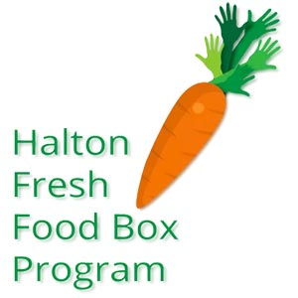 → 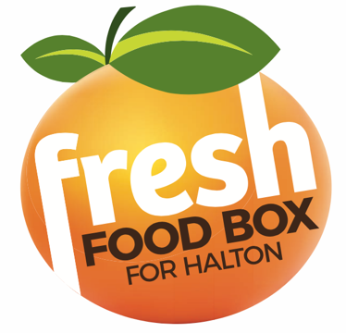

Fresh Food Box for Halton is a relaunch of the Halton Fresh Food Box program which operated pre-pandemic.

What’s Changed:

- The old program was managed by St. Christopher’s Anglican Church in Burlington. The new program is being run by Kerr Street Missions in Oakville.
- The old program ran once a month on the 3rd Tuesday. The new program runs twice a month on the 1st and 3rd Tuesdays.
- Fruit and vegetables were packaged by St. Christopher volunteers in the old program. Packaging has been sourced out to Forte Foods in the new program.
- Boxes were available in three sizes and price ranges previously (S-$10, M-$15, L-$20). Boxes now come in two sizes (S-$10, L-$20).
- Fruit and vegetables came in green bins to be transferred into customer provided bags before. Now the food comes pre-packaged in cardboard boxes to be taken home by the customer.
- The old program was located inside the building in the sanctuary of Grace United Church. It will now be run outside under the portico at the entrance to the church.
- Ontario Works (OW) clients were provided subsidized boxes under the program. Currently there is no subsidy for OW clients under the new program.
- Cash, credit card and PayPal were accepted as payment in the old program. eTransfer is the preferred method of payment in the new program using the email address FFBHatGrace@gmail.com.
- Ordering was done by phone, email or drop-in under the old program. Ordering is now done online each month by submitting an order form linked here, Order Form Fresh Food Box Halton at Grace

